**Project Plan**



**Table of Contents**

**1.0 Introduction 2**

1.1 Objective 2

1.2 Scope 2

**2.0 Management 4**

**3.0 Resources 7**

3.1 Software 7

3.2 Hardware 8

**4.0 Schedule 9**

4.1 Iteration 1 (September 4th - September 9th) 9

4.2 Iteration 2 (September 13th - October 3rd) 11

4.3 Iteration 3 (October 4th - October 24th) 13

4.4 Iteration 4 (October 25th - November 14th) 15

4.5 Iteration 5 (November 15th - November 26th) 16

4.6 Final Presentation & Demonstration (November 27th - December 10th) 17

**5.0 Risk Management 18**

5.1 Key Infrastructure 18

Software 18

5.2 Predicted Threats 18

5.3 Vulnerabilities and Risks 18

**6.0 Restrictions, Limitations, & Constraints 20**

6.1 Restrictions 20

6.2 Limitations 20

6.3 Constraints 20

**7.0 Revision Log 21**

# **1.0 Introduction**

## 1.1 Objective

Our group goal is to create a bot that advises understanding of the stock trading world. The bot should run on a trading strategy algorithm to inform the user about the current stock and whether they should trade it, buy it, or sell it. The bot will work as an extension of the Alpaca Application Programming Interface (API).

## 1.2 Scope

The team has been given a synopsis of the tasks they must complete to create an application for computerized stock trading:

* A Trend Trading Algorithm
* A Range Trading Algorithm
* Data acquired from Alpaca
* Alpaca (an Internet Trading Platform used to simulate a real trading platform)

The software project is being undertaken to develop a stock trading application based on an algorithm using data acquired from the Trend Trading strategy and Range Trading strategy. Our application will be executed any day from 9:30 am to 4:00 pm. Using Alpaca as our Internet Trading Platform, Profit Prophets will be funded $100,000 to use for our stock trading application. Project deliverables include documentation, individual and group timesheets and contributions, meeting minutes, and the software application itself. Our group, Profit Prophets, will review and approve the final documentation and application status before publishing. This project will not include option trading, and will only take a long or short position in a stock.

# **2.0 Management**

Everyone in the group has been assigned a resource lead and will work to contribute to each deliverable to ensure completion. When assigning, everyone’s strengths and weaknesses were considered when deciding who would be assigned to what role. Zaria Ascue was appointed as Project Manager (PM) by Dr. Muhammad and Dr. Chittenden and Harlem Morton was chosen to be Assistant Project Manager. Profit Prophets further divided the roles into Quality Assurance Officer, Info Assurance Officer, Programming Lead, and Strategy Analyst. Each resource lead is a member with strong expertise in a specific area and is eager to serve as a guide and resource for the group. This approach helps our team create an environment of collaboration, enabling everyone to gain insights into the various elements of each deliverable as we work together toward the final project.

| Title | Members Assigned | Description |
| --- | --- | --- |
| Project Manager (PM) | Zaria Ascue | Facilitates the total production of the team, and ensures deadlines and deliverables are up to team standard. Acts as the primary point of contact for all team members and addresses issues as they arise. |
| Co-Project Manager(Co-PM) | Harlem Morton | Shares ownership and responsibility for a project's outcome, and if the PM is not present, they are able to step in and ensure deadlines and responsibilities are met. |
| Quality Assurance Officer | Simisola Mumuni | Review documents and code to ensure accuracy, consistency, and completeness before submission. |
| Info Assurance Officer | Harlem Morton, Jayden Price | Safeguards critical info assets & data, through mitigation strategies while also assuring that information presented is accurate and correctly formatted before submission. |
| Programming Lead | Zaria Ascue, Angie Woodward | Leads the development and coding efforts, and manages the design and software implementation. |
| Strategy Analyst | Harlem Morton | Developing, optimizing, and managing the overall trading strategies implemented in the auto-trading stock bot. |

2.1 Communication and Meetings

We will conduct weekly in-person meetings and communication through group messaging.

1. Weekly Meetings: Weekly meetings will be held 2-3 times a week, based on the project’s necessities. Meetings will occur from 3:15 pm - 4:30 pm on Tuesday and Thursday; each meeting is subject to be extended based on the current workload of the team. Team members include Zaria Ascue, Harlem Morton, Simisola Mumuni, Jayden Price, and Angelina Woodward, who are each held to the expectation of attending all the group meetings where we will work together on enhancing the product and documentation for our final project. All in-person group meetings will be held in S&T Room 312B and in case of virtual meetings, we will utilize Zoom.
2. Group messaging: Team members will communicate with updates, scheduling, and reminders via iMessage and follow the Project Plan on Jira.

# **3.0 Resources**

## 3.1 Software

To effectively complete this project, we needed a multitude of tools. Since this is a group project, we need software development and collaboration software. This is especially important to ensure deliverables are completed promptly.

The software we intend to utilize:

| Tools | Descriptions |
| --- | --- |
| Github | GitHub will be used to host and update our source code as the tasks are completed. Also, this will be used to allow all team members to easily access and share the source code as needed. |
| Google Drive | Google Drive is a cloud storage service that lets users store and synchronize digital content across computers (Timesheets, Project Plan, Presentation, and Evaluation) |
| Jira | An issue-tracking product that allows bug tracking, agile, project management, and work management. |
| Visual Studios Code | Visual Studio Code is a source code editor that we decided to make edits to the existing code. |
| Python | Object-oriented programming language we are using to code the application. |
| Alpaca | Alpaca Trading is a modern financial platform that provides users with seamless access to algorithmic trading and investing through an API-first approach. With a focus on democratizing financial markets, Alpaca offers commission-free trading, robust tools for developing and executing trading algorithms, and easy integration with various financial data sources. |

## 

## 3.2 Hardware

The hardware utilized through the development of the project is listed below.

| Tools | Descriptions |
| --- | --- |
| Laptops | Personal use devices allow us to collaborate from various locations and open large documents. |
| Cellphones | Cellular devices allow us to communicate with each other from long distances and on the go. |
| Computers | Computers located in S&T 127 in which Profit Prophets has gained admin access to in order to run applications such as Visual Studio Code and Python. |

# 

# **4.0 Schedule**

## 4.1 Iteration 1 (September 4th - September 9th)

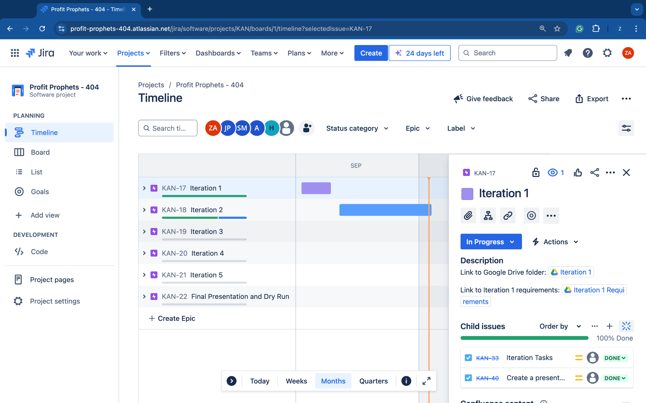

* Download all documents from project teams Code Craft and Auto Stock.
* Assign team roles and expectations.
* Take an opportunity to learn and understand team members.
* Create a project plan on a Microsoft project to track progress and work that needs to be completed.
* Evaluate and critique both Code Craft and Auto Stock, and deep dive into each file within the final project submission of the projects.
* Research trading strategies, and understand how and why they are used.
* Decide on a project to use as a foundation for the semester.
* Organize, prep, and present a presentation on the final project to move forward with for the semester as well as inform the audience of the critiques of both projects after evaluation.
* Update individual timesheets and organize group timesheets to reflect the work put in and out of team meetings throughout the iteration. Update the meeting minutes for submission.

## 4.2 Iteration 2 (September 13th - October 3rd)

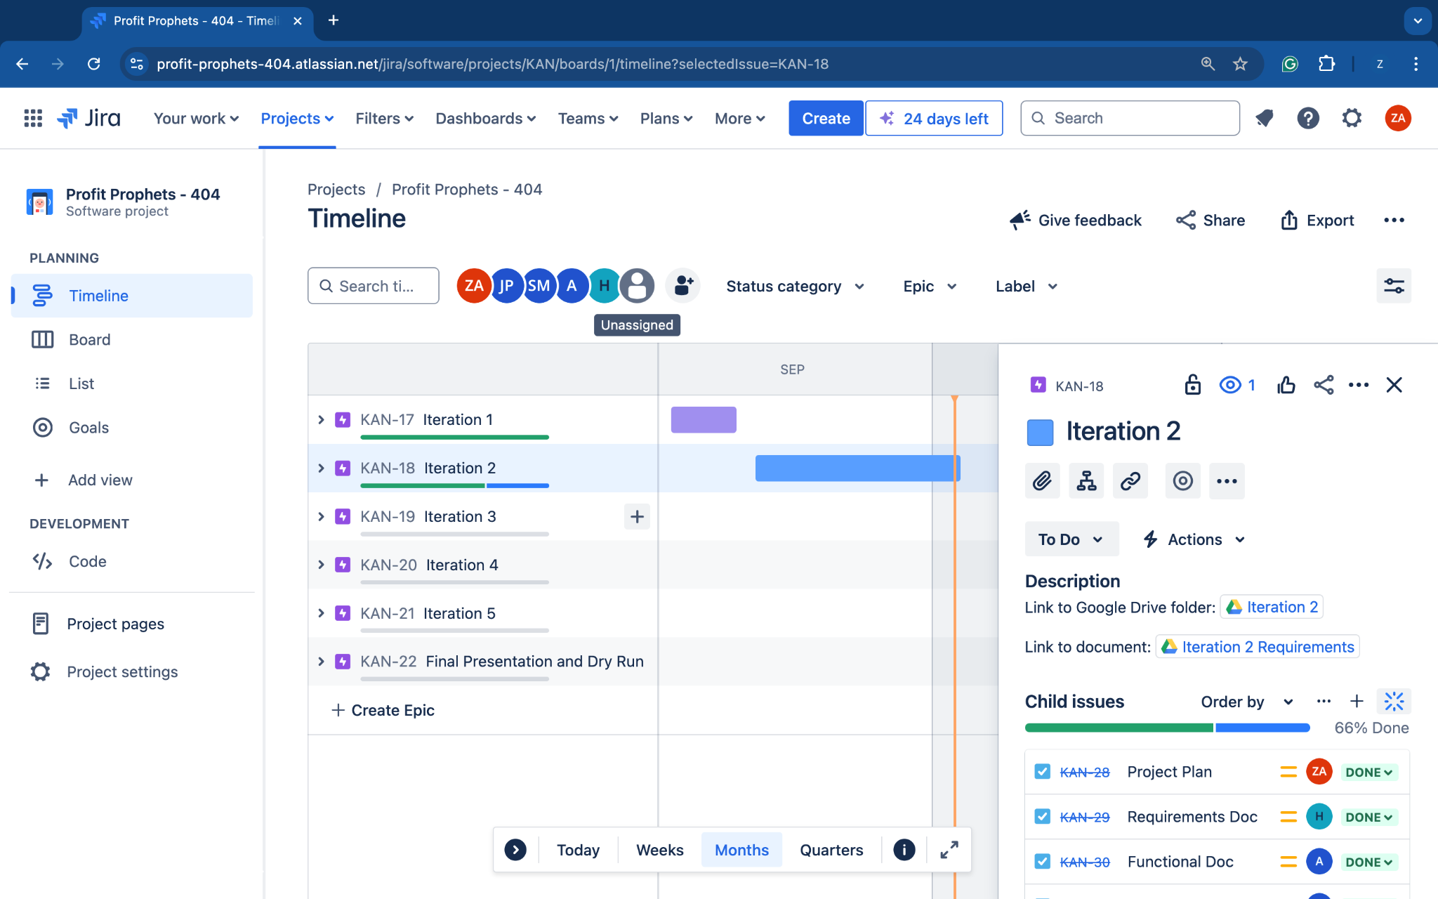

* Implement the team tasks for Iteration 2 on Jira.
* Edit and resolve the critiques that were highlighted in Iteration 1.
* Elaborate and execute the team's goals throughout the documents for Iteration 2.
* Research trading strategies to implement, and ensure that the strategy is supported by Alapca API.
* Update individual timesheets and organize group timesheets to reflect the work put in and out of team meetings throughout the iteration. Update the meeting minutes for submission.
* Submit a running program that supports a specific trading methodology.
* Complete document updates on the Project Plan, Requirements Document, Functional Specification, Design Specification, and Test Plan.

## 4.3 Iteration 3 (October 4th - October 24th)

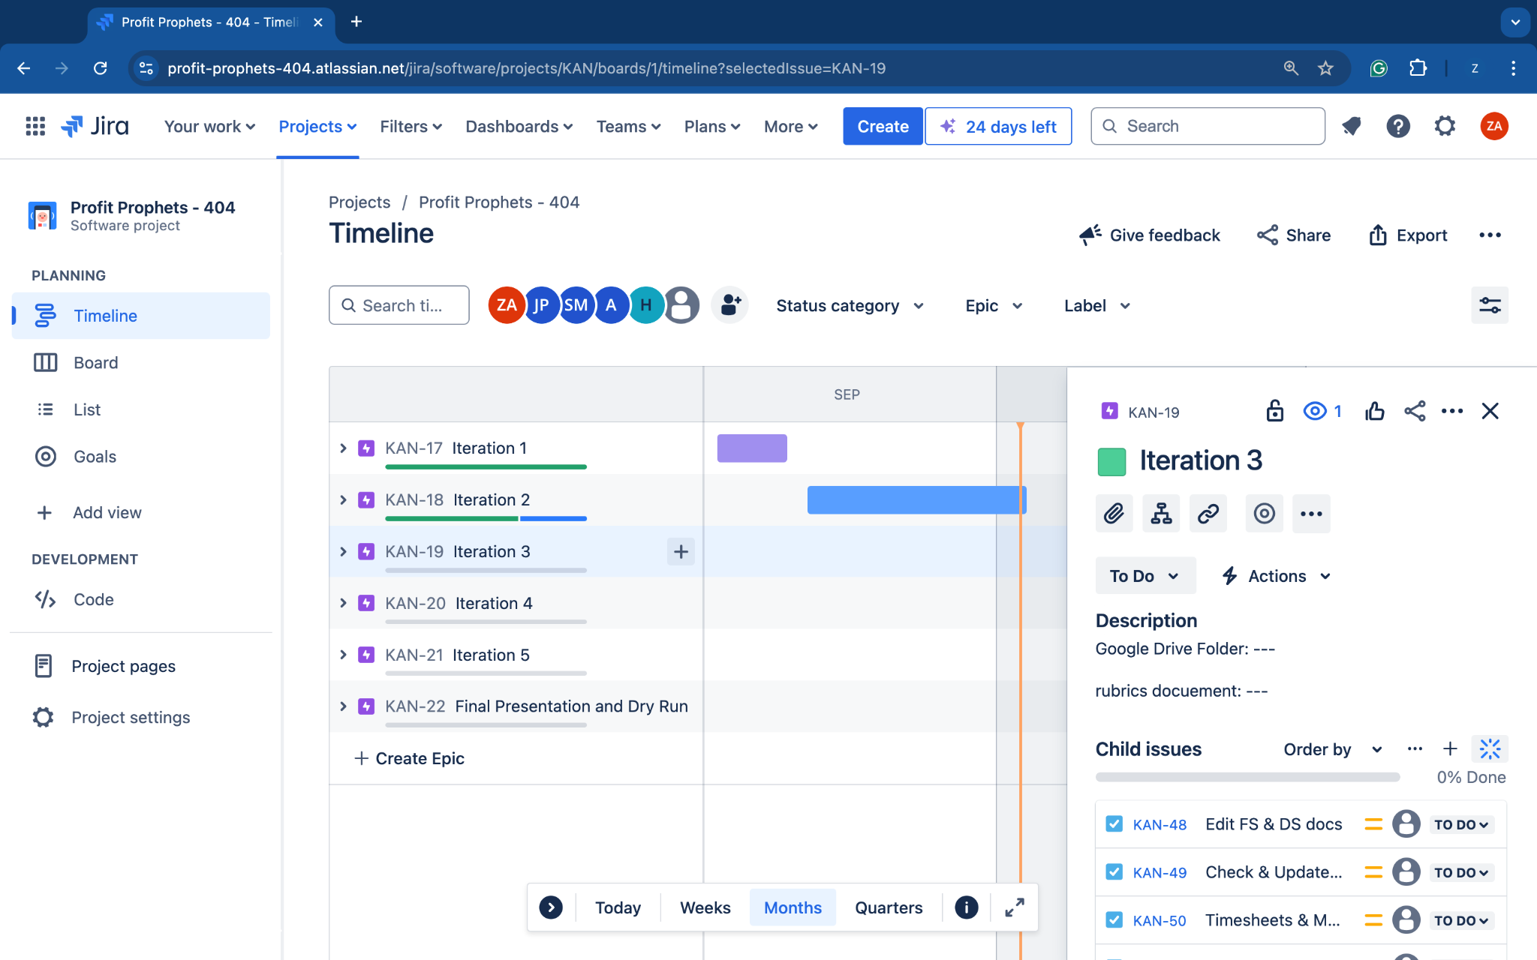

* This iteration is about the Implementation and Unit Testing.
* Review and edit the Functional Specification and Design Specification documents.
* The initial prototype now becomes an early version of the product.
* Work to complete the formal deliverables assigned including the updated Functional Specification and Design Specification documents. Acknowledge that the complete documentation package including all five documents (Project Plan, Requirements Document, Functional Specification, Design Specification, and Test Plan) will be submitted in this iteration.
* Update individual timesheets and organize group timesheets to reflect the work put in and out of team meetings throughout the iteration. Update the meeting minutes for submission.

## 4.4 Iteration 4 (October 25th - November 14th)

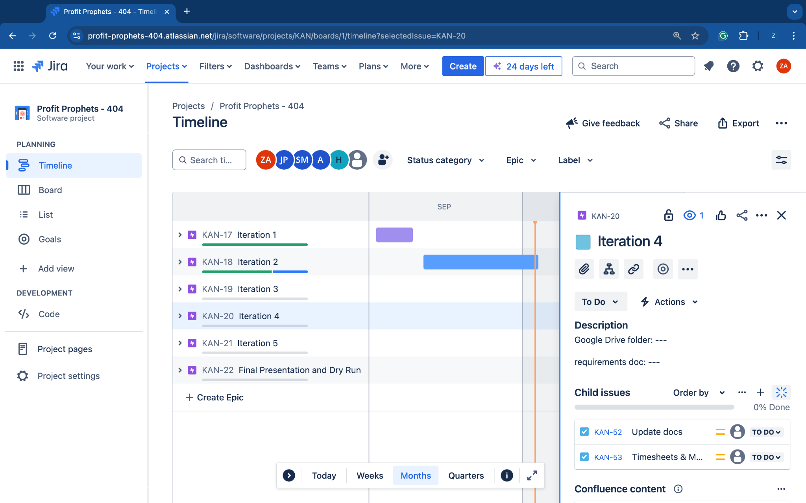

* Iteration focuses on the Product.
* The Design Specifications should be largely completed.
* Focus shifts to the Product and the Test Specification.
* Early versions of the Product now become a Beta Release of the product and should include a Readme as to how to install and run the product.
* Formal deliverables are the Beta Release of the Product and the Test
* Updated versions of all the Documents that reflect changes as the project evolves should also be submitted.
* Update individual timesheets and organize group timesheets to reflect the work put in and out of team meetings throughout the iteration. Update the meeting minutes for submission.

## 4.5 Iteration 5 (November 15th - November 26th)

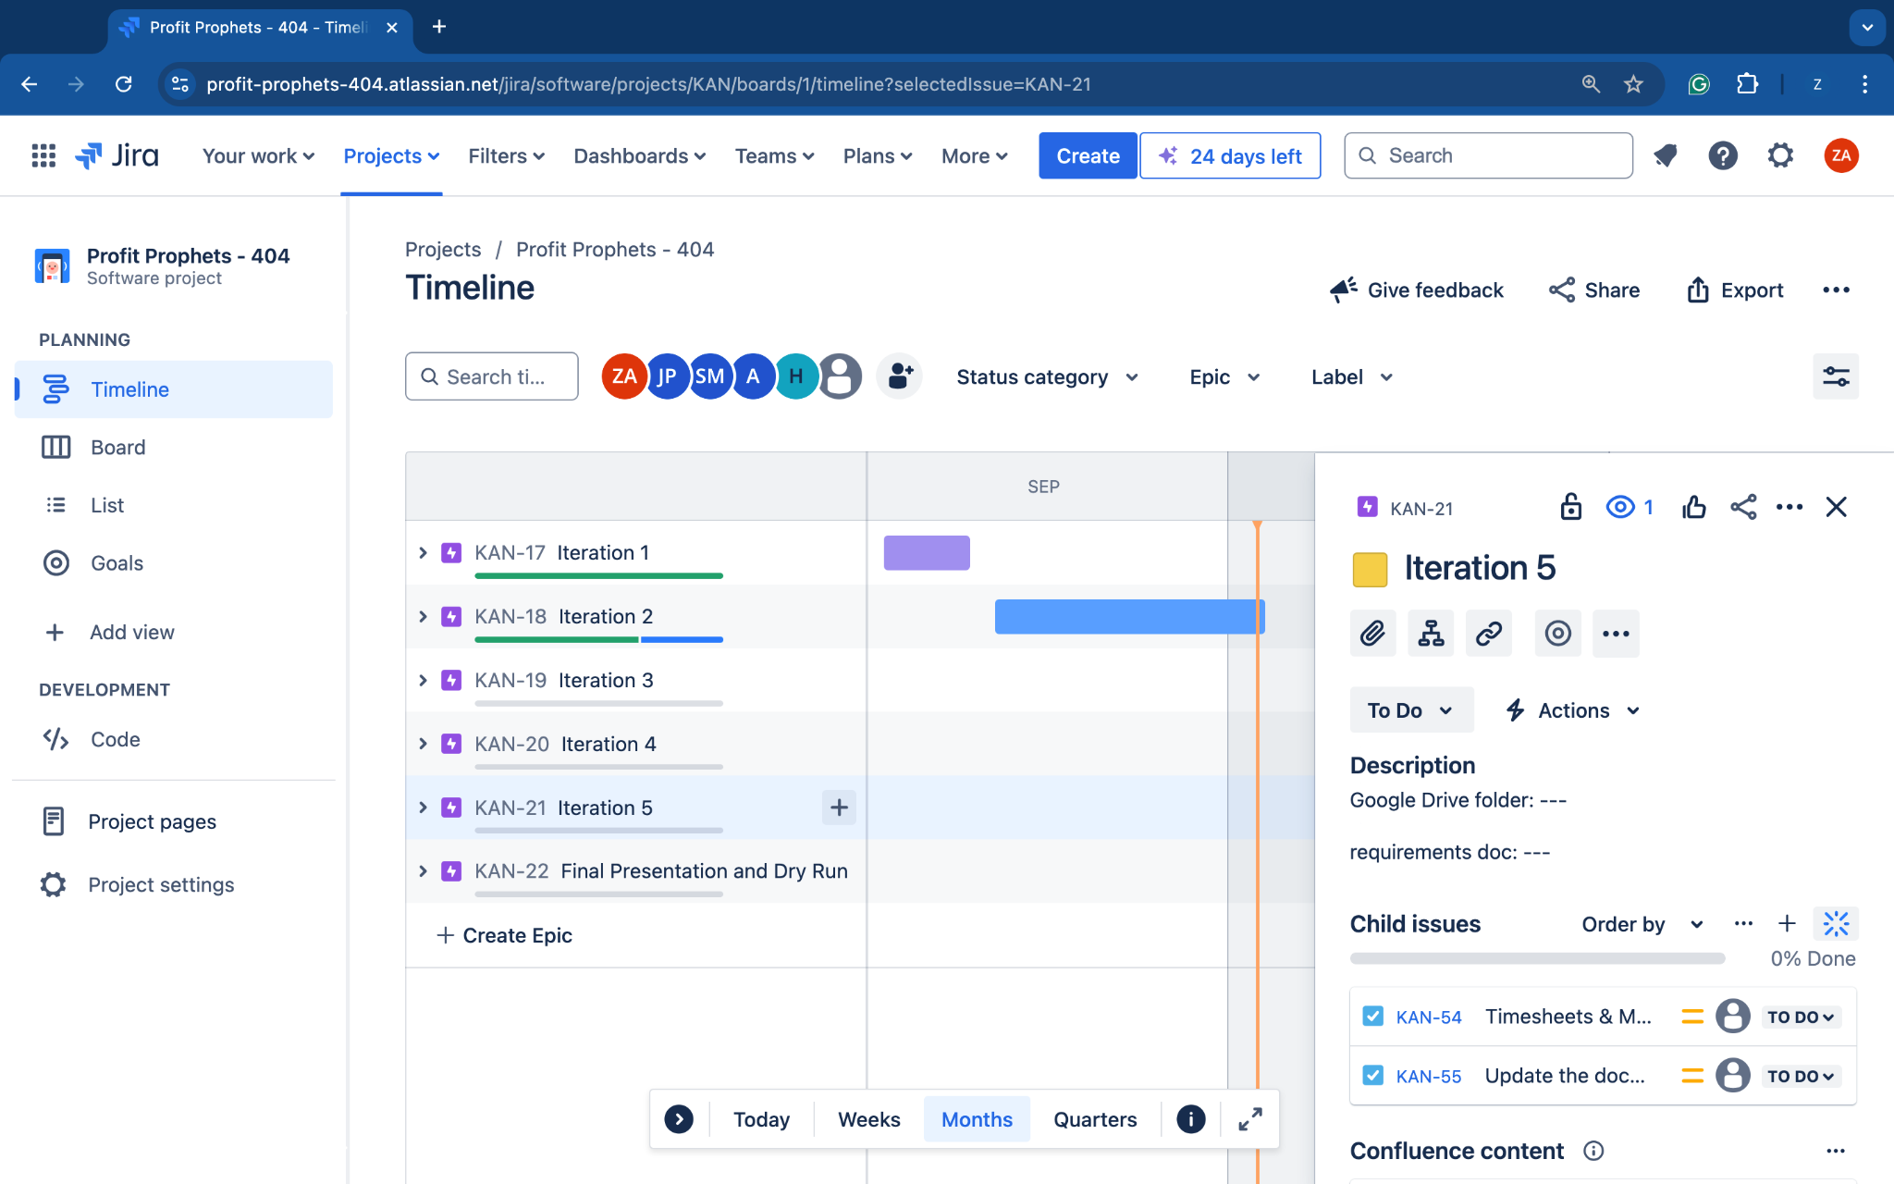

* This iteration is all about the Product.
* The Test Specifications should be largely completed.
* The focus shifts to the Product and Testing.
* Early versions of the Product now become a Release Candidate of the product.
* Formal deliverables are the Release Candidate of the Product and the complete set of Documentation for the project.
* Updated versions of all the Documents that reflect the Final Product should be submitted.
* Update individual timesheets and organize group timesheets to reflect the work put in and out of team meetings throughout the iteration. Update the meeting minutes for submission.

## 4.6 Final Presentation & Demonstration (November 27th - December 10th)

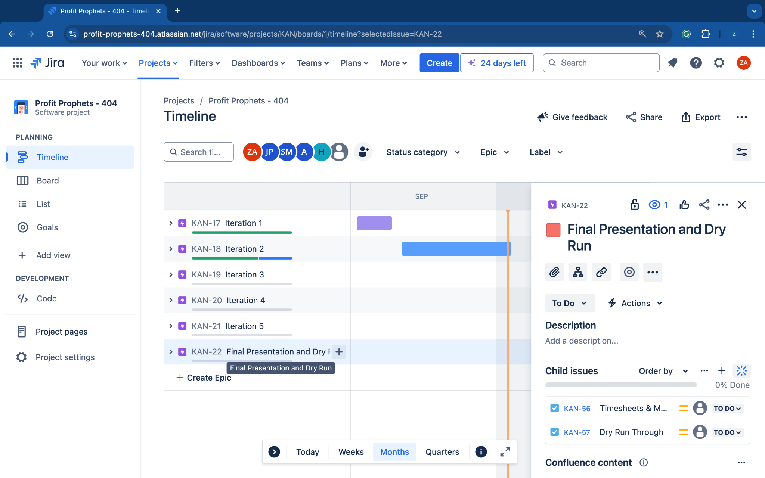

* Update individual timesheets and organize group timesheets to reflect the work put in and out of team meetings throughout the iteration. Update the meeting minutes for submission.
* Dry run for final.

# **5.0 Risk Management**

As with any project, risks are inevitable. To address and mitigate them effectively, we will outline the specific risks, their potential impact on the project, and the best strategies for minimizing each one.

## 5.1 Key Infrastructure

## Software

* Visual Studios
* Google Drive
* Jira (forecasting)

Hardware

* Personal Computers
* Desktop Computer

## 5.2 Predicted Threats

* Computer Exposure
* Cyber Attacks
* Stock Changes

## 5.3 Vulnerabilities and Risks

Vulnerabilities

* *Trend and Range Trading Algorithm Bugs*: Errors in the algorithm could lead to poor trade decisions, including buying at peaks or selling at lows. This could result in significant financial losses.
* *Alpaca API:* The project depends heavily on Alpaca for data and trade execution. Any disruptions in Alpaca’s services or changes in their API could negatively impact the project.
* *Rate Limits and API Downtime:* Many trading platforms instill rate limits on their APIs, meaning too many requests could result in missed trade opportunities. This could result in the downtime or outages in Alpaca's services slowing or stopping trading activities.

Risks

* The market is open from 9:30 and closes at 4:30 if you missed your window to buy or sell stocks.

# **6.0 Restrictions, Limitations, & Constraints**

## 6.1 Restrictions

* *Time:* The stock market is only open from 9:30 am - 4:00 pm. It restricts the group from viewing the trends of companies chosen in the morning and at night as well.

## 6.2 Limitations

* Ensuring the completion of all tasks before the scheduled delivery date may result in certain elements being incomplete or hastily done due to tight time constraints.

## 6.3 Constraints

* *Experience:* Not everyone on our team is equally experienced in Python, which could potentially force us to spend more time learning the language. However, having different levels of expertise in Python and probabilities will benefit our team and allow opportunities for certain members to guide others and build each other up. We can assign tasks based on individual skills, allowing us to divide and conquer our work more efficiently.
* *Time:* To meet our project's deadline, we're using timesheets to keep our team organized and on schedule. Some team members, who are familiar with Python, are dividing the coding tasks among themselves to ensure efficient project completion.

# **7.0 Revision Log**

| Revision | By | Date | Description |
| --- | --- | --- | --- |
| 1.0 | Profit Prophets | 09/09/2024 | Project Plan for Iteration 1. |
| 2.0 | Profit Prophets | 10/01/2024 | Project Plan for Iteration 2. |
| 3.0 | Profit Prophets | 10/11/2024 | Updated Project Plan for Iteration 2. |
|  |  |  |  |
|  |  |  |  |